Aurora Ranzani, Id: 84455A
Artificial Intelligence a.a.2025/2026
Professor: Raffaella Folgieri
Università degli Studi di Milano

Breast Cancer Detection through MLP Neural Networks
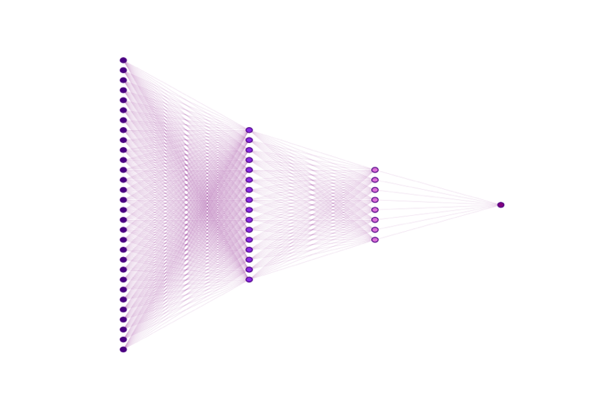
1. Introduction
The aim of the present project is to build a system capable of detecting the presence of breast cancer, by classifying a tumour either as malignant (1) or benign (0). The identification will happen through a MLP artificial neural network trained on the Wisconsin breast cancer dataset, available on the UCI Machine Learning Repository.
While the use of GUI-based NN simulators - like JustNN - was taken into consideration, I chose a Python-based implementation using the Scikit-Learn library: this approach offers greater transparency and stability, as I will discuss in section 4.

2. The Dataset
2.1 The Algorithmic Origin of Features
I selected a multivariate dataset – accessible on UCI Machine Learning Repository - which takes into analysis 30 numeric features (computed from a digitized image of a fine needle aspirate (FNA) of a breast mass) to predict the diagnosis with high accuracy.
It is relevant to note that these input features are themselves the product of an antecedent algorithm (known as Active Contour Models, or snakes) defined as "an energy-minimizing spline guided by external constraint forces and influenced by image forces that pull it toward features such as lines and edges".
Unlike static detection, this "active" model iteratively deforms itself to lock onto cell boundaries, balancing smoothness constraints with image gradients: therefore, any neural network built on this dataset (as the present is) is effectively a second-order system, learning from data previously processed by this initial energy-minimization algorithm.

2.2 Cleaning and Preprocessing data
To ensure the stability of the NN the raw data required specific preprocessing steps. First, I used a 80/20 data split to divide the patients into two groups, devoting 80% of data to train the model, while the remaining 20% for testing.
Secondly - since the initial input features vary significantly in magnitude - I applied Standardization using StandardScaler, a tool that rescales every feature so that they all have a mean of 0 and a standard deviation of 1. To prevent data leakage, the scaler was fit exclusively on the training set and then applied to the test set, ensuring that no statistical information from the “test data” would influence the training process.

3. Model Architecture, Training and Results
3.1 Network Topology
I implemented a MLP with a specific topology designed to condense information. The network is structured as follows:
- Input Layer: 30 Neurons, corresponding to the 30 features of the dataset.
- Hidden Layer n.1: 16 neurons.
- Hidden Layer n.2: 8 neurons.
- Output Layer: 1 neuron that results in a probability score (a value closer to 1 indicates malignancy, while a value closer to 0 indicates a benign tumour).

3.2 Activation Functions
To allow the network to learn, specific activation functions were used:
- ReLU (Rectified Linear Unit), applied to the hidden layers: it allowed me to introduce non-linearity into the model and to block irrelevant information while amplifying positive signals.
- Sigmoid function, applied to the output layer: it translates the final number calculated by the network into a strict probability range.

3.3 Training Parameters
- Optimization: The model was trained using the Adam (Adaptive Moment Estimation) solver, an “algorithm for first-order gradient-based optimization of stochastic objective functions”.
I employed the Adam algorithm - in place of the traditional Stochastic Gradient Descent (SGD) - in view of the fact that it better suits my dataset’s nature: unlike SGD, Adam computes individual adaptive learning rates for different parameters, making it particularly advantageous for the Breast Cancer dataset, where the 30 input features have different statistical properties even after normalization.
In addition, Adam incorporates Momentum by default, whereas SGD requires manual tuning of Momentum parameters, frequently leading to trial-and-error instability.

- Max iterations: While the default is often lower, I set this to 500 epochs to guarantee the solver has sufficient time to reach convergence effectively.

- Random State: the value was fixed at 55 (randomly picked value). As noted by the Scikit-learn developers, fixing this seed is essential to guarantee that the algorithm's performance is valuable and reproducible.

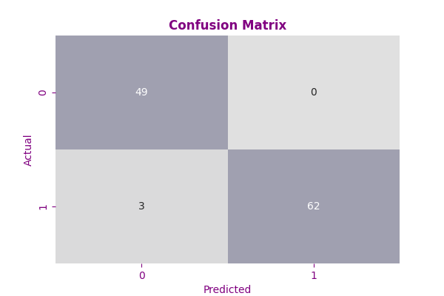
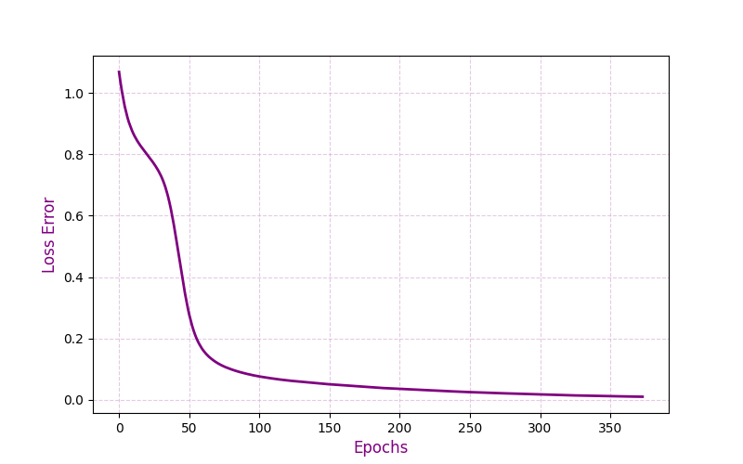
3.4 Results and Discussion

Figure 1. Model evaluation metrics: the learning curve and the confusion matrix

The training progress is visualized in Figure 1.
In the learning curve the x-axis represents the number of training iterations (epochs) and the y-axis represents the loss error, i.e. the divergence between predictions and actual diagnoses. The curve exhibits a sharp decline during the first 100 epochs, meaning that the network rapidly identified the primary patterns, distinguishing malignant from benign tumours. Following this initial drop, the curve then stabilizes around zero, demonstrating that the model has been able to minimize the prediction error.
Final Accuracy Reached: 97.37%.

4. Methodological Reflections
4.1. Overcoming the Topology Design Problem in JustNN
A significant decision in this project was the transition from GUI-based tools to a code-based environment.
Indeed, my initial attempt, which involved using JustNN, proved unsuccessful: while the graphical interface offered immediate ease of use, I found that the tool functioned largely as a “black box”, obscuring the underlying mathematical operations. More critically, it imposed arbitrary constraints on the architecture: specifically, it prevented me from freely designing the “funnel” topology I had envisioned to compress the features effectively.
By implementing the model in Python, I achieved architectural transparency and scientific reproducibility. Specifically, the use of a fixed random seed ensures that the result can be exactly replicated by any researcher on any machine. This level of rigor is difficult to guarantee with drag-and-drop software.

4.2 Handling Data Leakage
During the initial development phase, an early version of the model resulted in suspiciously high accuracy rates (>98%) within the first few epochs. This motivated me to review the preprocessing path and identify a critical methodological error: the data normalization had been applied to the entire dataset before splitting it into training and testing sets. This approach inadvertently caused "data leakage", rendering the evaluation invalid.
To correct this, I restructured the pipeline to strictly separate the two stages: this correction ensured that the test set remained truly "unseen" data, simulating the real medical scenario where a model must make predictions on new patients without prior knowledge of their statistical distribution. Although this rigorous approach slightly adjusted the final accuracy to 97.37%, the result is statistically robust and scientifically valid.

5. Conclusion: Epistemological Reflection and Limitations
This project successfully implemented a MLP capable of classifying breast cancer tumours with 97.37% accuracy.
However, while the accuracy of the present model is high, it is important to note that the dataset contains only 569 samples: in a real diagnostic and clinical setting, this sample size would be insufficient for deployment. Hence, future developments would require validation on a significantly larger and more diverse demographic to ensure the model has not overfitted to this specific statistical distribution.
Beyond these statistical matters, this project inspires a broader epistemological reflection on the nature of medial AI, whose effectiveness is often the result of hybrid systems: as noted by Kass, Witkin, and Terzopoulos in their work, the goal of the active contour algorithm was to “leave a much simpler problem for higher level processing”. This project fulfils that theoretical projection: the snake algorithm acted as the perceptual mechanism (segmenting the visual reality), while the MLP functioned as the cognitive engine (interpreting the abstract features).
This synergy suggests that the reliability of diagnostic AI relies not merely on the complexity of the neural network, but on the quality of the algorithmic “vision” that precedes it.

References
Kass, M., Witkin, A., & Terzopoulos, D. (1988). Snakes: Active Contour Models. International Journal of Computer Vision, pp.321–331.
Kingma, D. P., & Ba, J. (2017). Adam: A Method for Stochastic Optimization. Published as a conference paper at the 3rd International Conference for Learning Representations, San Diego, 2015 (ICLR). Available at: https://arxiv.org/abs/1412.6980.
Pedregosa, F., Varoquaux, […], Duchesnay, E. (2011). Scikit-learn: Machine Learning in Python. Journal of Machine Learning Research, 2825–2830. Available at: https://www.jmlr.org/papers/volume12/pedregosa11a/pedregosa11a.pdf .
Scikit-Learn Developers. MLPClassifier - User Guide. Available at: https://scikit-learn.org/stable/modules/neural_networks_supervised.html. Accessed: 20/01/26
Scikit-Learn Developers. (2023). sklearn.neural_network.MLPClassifier API Reference. Available at: https://scikit-learn.org/stable/modules/generated/sklearn.neural_network.MLPClassifier.html. Accessed: 21/01/26
UCI Machine Learning Repository. Breast Cancer Wisconsin (Diagnostic) Data Set. Available at: https://archive.ics.uci.edu/dataset/17/breast+cancer+wisconsin+diagnostic Accessed: 20/01/26
Van Rossum, G., Drake, F.L., Python Language Reference. Release 3.1.1, Python Software Foundation, 2009. Available at: https://elhacker.info/manuales/Lenguajes%20de%20Programacion/Python/Pyhon%20Languaje%20Reference,The%20(v3.1.1)%20-%20Guido%20van%20Rossum%20-%202009;108pags.pdf.

UCI Machine Learning Repository. Breast Cancer Wisconsin (Diagnostic) Data Set. Available at: https://archive.ics.uci.edu/dataset/17/breast+cancer+wisconsin+diagnostic
See p.4, Section 4.1.
Kass, M., Witkin, A., & Terzopoulos, D. (1988). “Snakes: Active Contour Models”. International Journal of Computer Vision, pp.321–331.
On this topic, see pag.5, section 4.2.
Kingma, D. P., & Ba, J. (2017). Adam: A Method for Stochastic Optimization. Published as a conference paper at the 3rd International Conference for Learning Representations, San Diego, 2015 (ICLR).
Pedregosa, F., Varoquaux, G., Gramfort, A., Michel, V., Thirion, B., Grisel, O., ... & Duchesnay, E. (2011). Scikit-learn: Machine Learning in Python. Journal of Machine Learning Research, 2825–2830.
Kass, M., Witkin, A., & Terzopoulos, D. (1988). “Snakes: Active Contour Models”. International Journal of Computer Vision, pp.321–331.

